1. In last lecture, we saw the usage of flags –it.
2. **Agenda**: The usage of exec in command 🡺 docker **exec –it redis-cli.**This is going to be the most common usage that you’re going to be making use of on your own **personal projects**.
3. A very common thing that you’re going to want to do when you’re using docker is to get shell access or terminal access to your running container.   
   In other words, you’re going to what to run commands inside of your container without having to rerun doc exec again and again all day.  
   So, we will see how to open a shell in the context of a running container.
4. 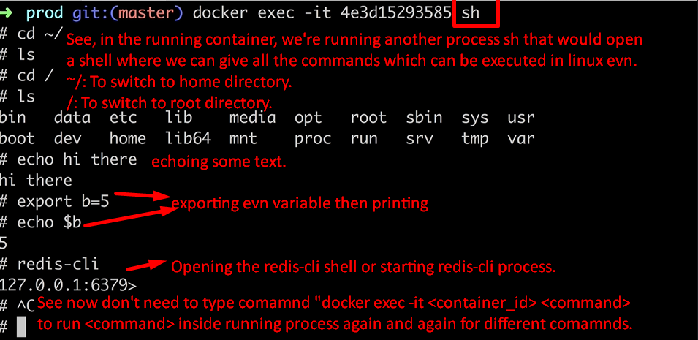
5. To come out of the running container, press CTRL + D.
6. What is SH?
7. 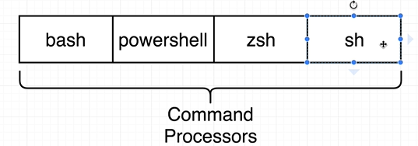  
   Name of a program. It is a program that is executed inside the running container.   
   It’s a command processor or shell.   
   It allows us to type a command in and have them executed inside the container.  
   You’re already using use of a program very much like SH on your own computer.  
   If you’re on **MAC OS** 🡺 bash.  
   Windows: Git Bash or Powershell.
8. 